
Report

Team ID | MCA
Project Name | Online Learning Engagement and Student Performance Analysis
Maximum Marks | 5 Marks

Online learning platforms generate large volumes of data related to student participation, learning activities, study time, course completion, assessments, and academic performance. However, raw data is often difficult to interpret and does not provide an immediate understanding of student learning behavior and performance.
The Online Learning Engagement and Student Performance Analysis project aims to develop a comprehensive Power BI report that organizes and visualizes student engagement and academic performance data in a structured and understandable manner. The report will use interactive charts, graphs, KPI cards, tables, filters, and slicers to present important information and support detailed a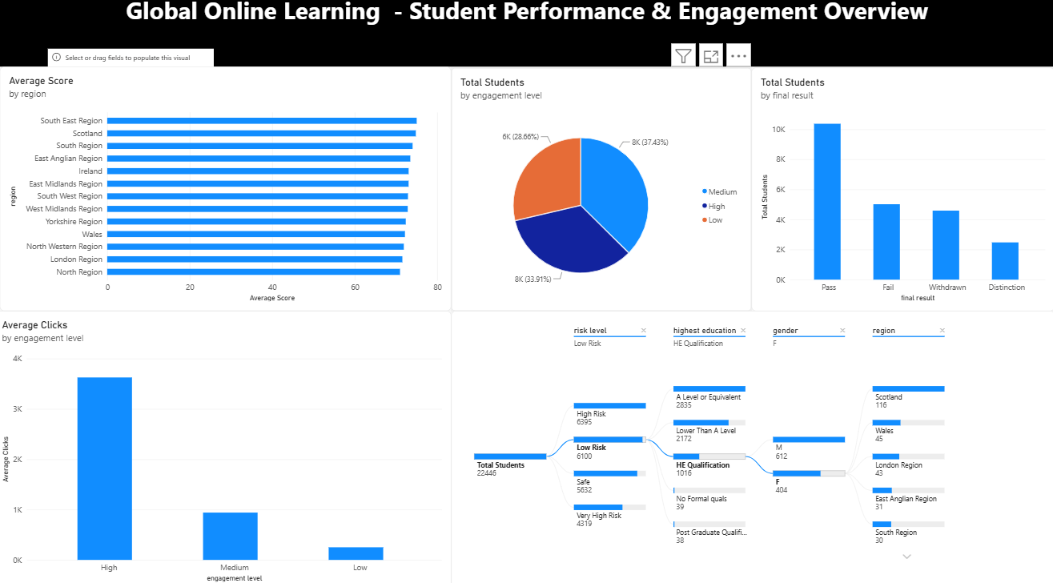n

Key Analysis Areas
- Performance Trends
  - Analyze changes in student scores and academic performance across different time periods to identify performance patterns and trends.
- Engagement Analysis
  - Examine student participation, study time, activity levels, and interaction with online learning resources to understand engagement patterns.
- Performance Comparison
  - Compare student performance across different courses, student groups, engagement levels, or other relevant categories to identify variations in academic outcomes.
- Course Completion Analysis
  - Analyze course completion and dropout rates to identify patterns among students who successfully complete or discontinue their courses.
- KPI Analysis
  - Monitor important Key Performance Indicators (KPIs), such as total students, average score, completion rate, engagement level, and dropout rate, to provide a summarized view of the overall learning environment.
Expected Outcomes
- Identify important trends and patterns in student performance.
- Understand the relationship between online learning engagement and academic performance.
- Identify student groups with different levels of engagement and performance.
- Analyze course completion and dropout patterns.
- Provide interactive visualizations for easier exploration of student data.
- Present meaningful insights through a Power BI report and dashboard.
- Support data-driven decision-making for improving online learning outcomes.

